**SE ASSIGNMENT :**

**ROLL NUMBER : 28**

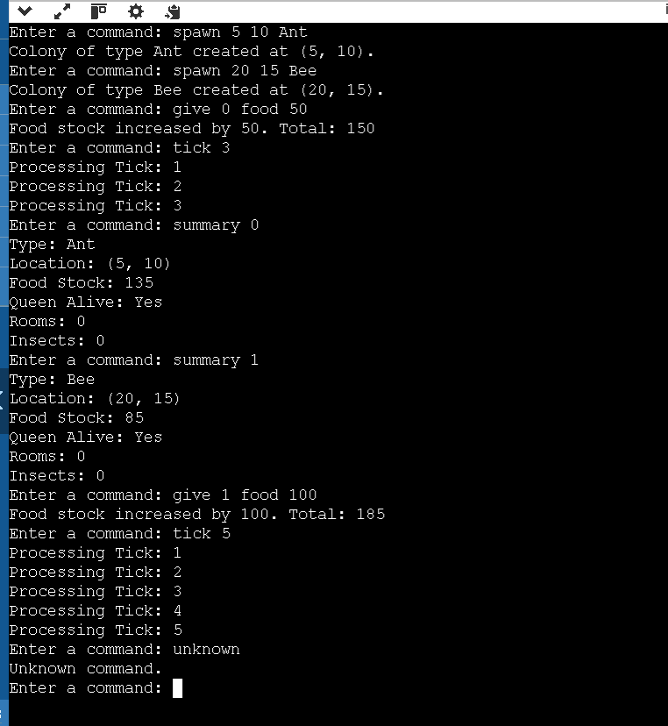

**OBSERAVTION :**

The provided code implements a simulation of a meadow ecosystem, featuring colonies of insects with unique characteristics. It is structured using design patterns such as Builder, Singleton, Decorator, and Factory, which enhance its modularity and flexibility. The Meadow class, implemented as a singleton, manages the colonies and ensures that only one instance of the meadow exists throughout the program. Colonies are represented by the Colony class, which maintains attributes like position, food stock, and whether the queen is alive. Each colony can add rooms, host insects, and process periodic "ticks" during which food consumption occurs. If food runs out, the queen dies.

The Room class is a basic builder that creates rooms for colonies, while the Insect class hierarchy represents insects with different attributes. Using the Decorator pattern, insects can be enhanced with traits such as being "Powerful" or "Resourceful." The Factory pattern is employed to generate insects based on categories like "Worker" or "Fighter."

The program includes a user-friendly command-line interface that allows users to interact with the simulation by spawning colonies, allocating resources, executing ticks, and viewing colony summaries. Commands like spawn, give, tick, and summary enable dynamic management of colonies and their attributes. The overall design is robust and extensible, making it suitable for future enhancements such as additional colony types, insect traits, or resource types.